## Assignment 1 :

Initialize a new Git repository in a directory of your choice. Add a simple text file to the repository and make the first commit.

**Step 1 :** Open GitHub and write repository name and make it public and then click on Create repository Button given below. Your repository will be created.

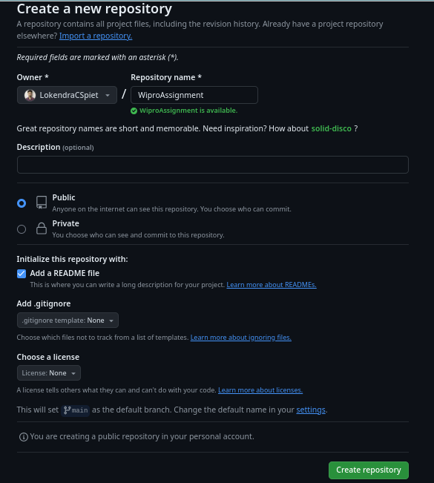

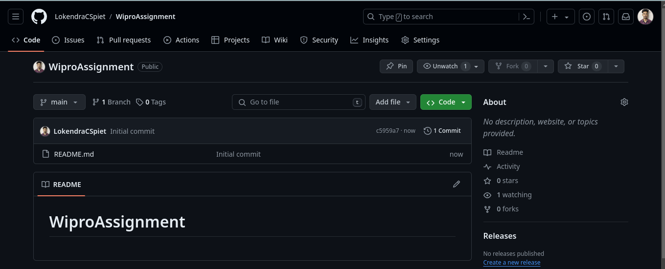

**Step 2 :** Create a new folder in local directory and open in the command prompt

**Step 3 :** Clone the repository by command – git clone __project-url__

**eg:** git clone https://github.com/LokendraCSpiet/WiproAssignment.git

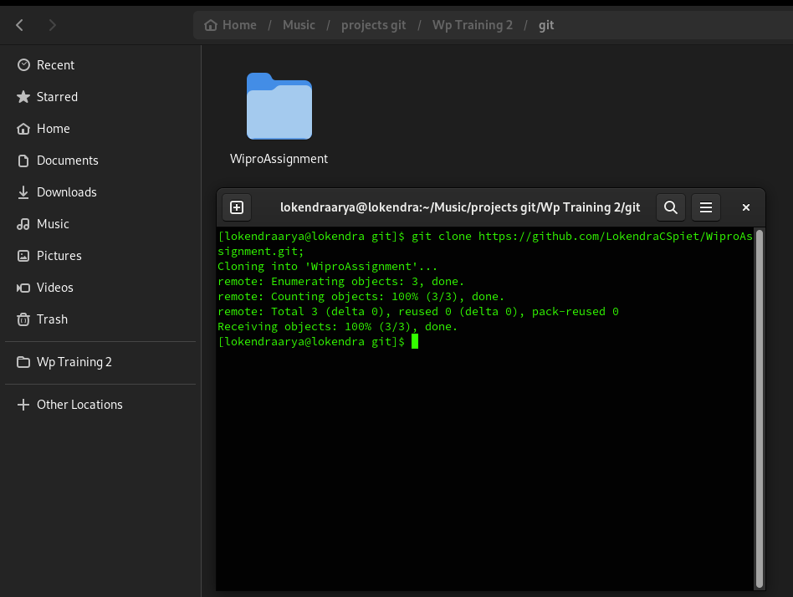

**Step 4 :** Open this Project in VS code or any IDLE and create a new file

**Step 5 :** Open git section in VS code and add this file to staged changes

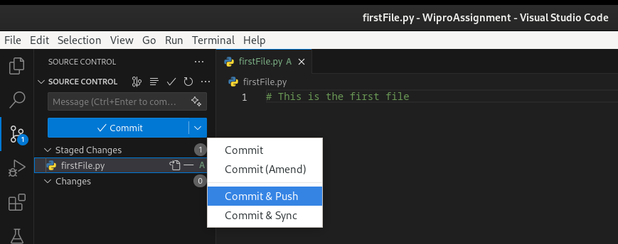

**Step 6 :** Now write commit message and click on Commit & Push Button, It will commit your staged changes to git.

**Step 7 :** Check git repository your file will be added in repository.

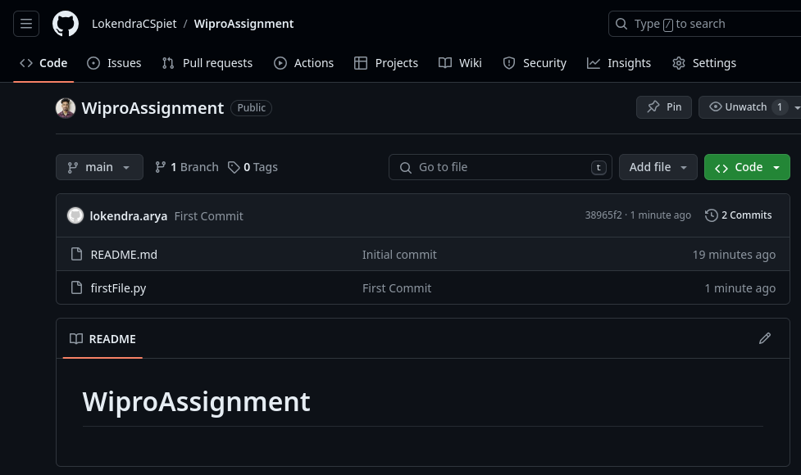

## Assignment 2 :

Create a new branch named 'feature' and switch to it. Make changes in the 'feature' branch and commit them.

**Step 1** : Switching into a new branch, main to feature

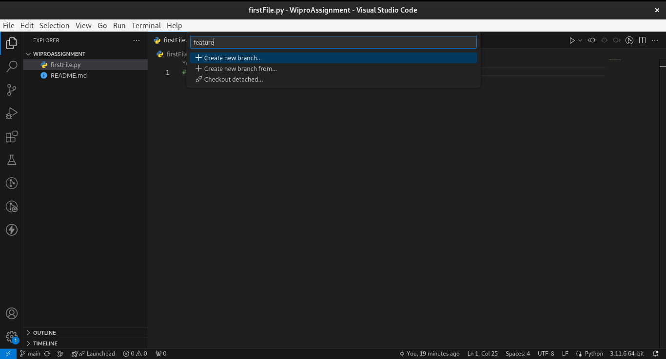

**Step 2 :** Now create two files and add into stages in our new branch feature.

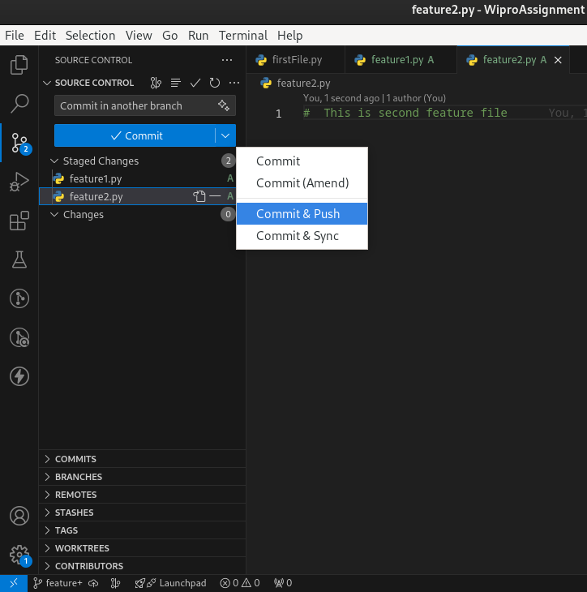

**Step 3** :Now we will see Compare & pull Request in our repository. Click on it and create a pull request and then merge pull request

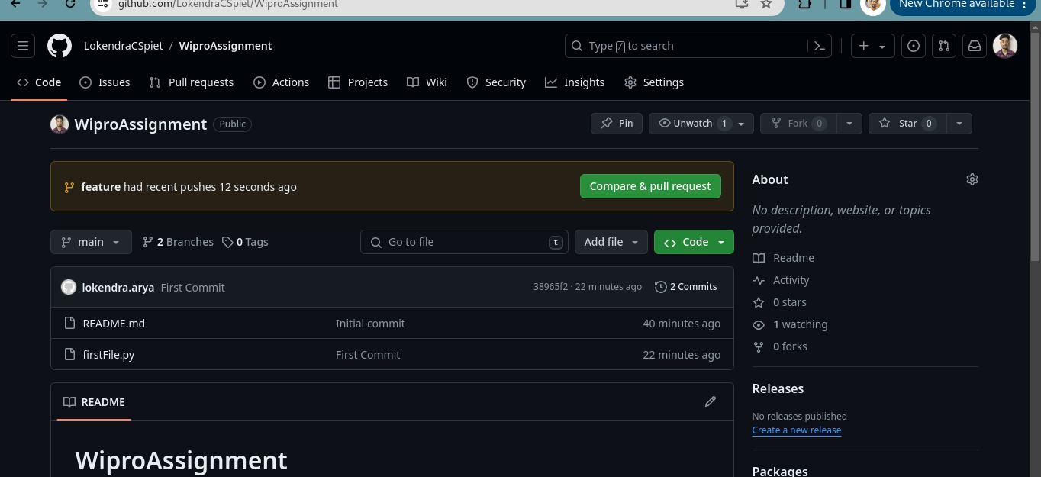

**Step 4 :** After merge we can see our both new file in our repository

